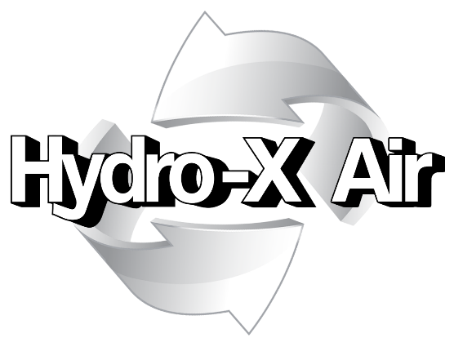

Kitchen Deep Cleaning
Report

Main kitchen

at
Building No1

INDEX

 | Section
Preface | 1
Introduction | 2
Photographic Evidence | 3
Certification | 4

Section 1: Preface

Customer: | Customer
Site Address: | Building No1
Hydro-X Account Manager: | Account Manager
Account Manager Telephone Number: | 0123456789
Account Manager Email Address: | Account.Manager@hydro-x.co.uk
Hydro-X Address: | Unit 1, Manor Drive,  Dinnington,  Sheffield.  S25 3QU
Hydro-X Telephone Number: | 01909 565133
Hydro-X Email Address: | info@hydro-x.co.uk
Hydro-X Operatives Carrying Out Works: | Site personnel names
Date of Assessment: | Date

Any further information concerning this assessment should be requested by contacting the above named Hydro-X Account Manager.

Section 2: Introduction

Hydro-X Air Ltd were instructed to undertake a deep clean of kitchen at (Site Name). The works were completed on (Date).

Hydro-X Air Ltd can certify that the above areas have been cleaned in accordance with the enclosed method statement and as agreed with the client requirements

Section 3: Photographic Evidence

Before Photo, Main Kitchen Tables

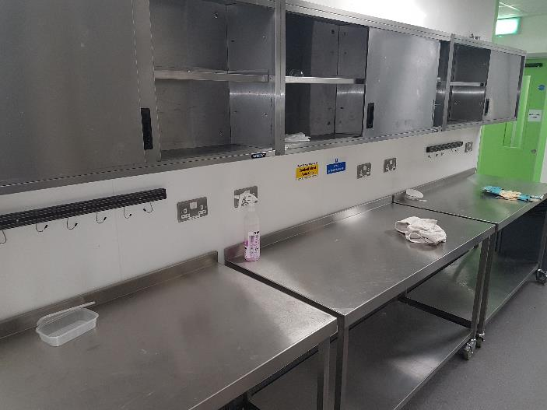

After Photo, Main Kitchen Tables

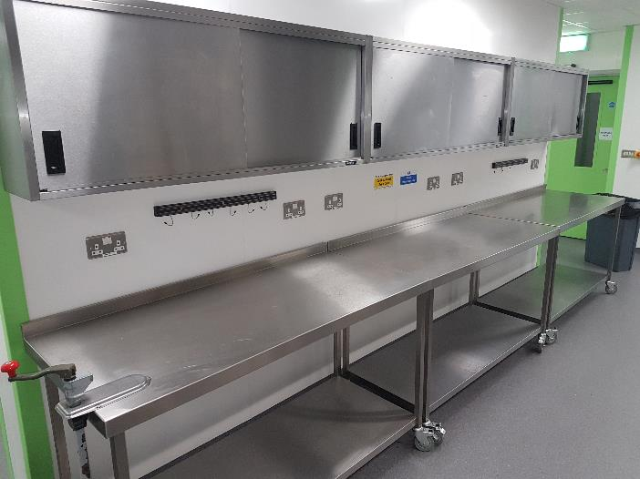

Before Photo, Main Kitchen Walls

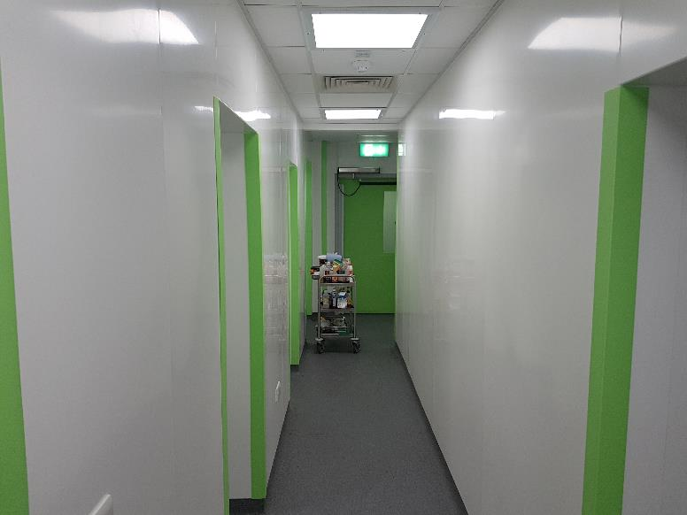

After Photo, Main Kitchen Walls

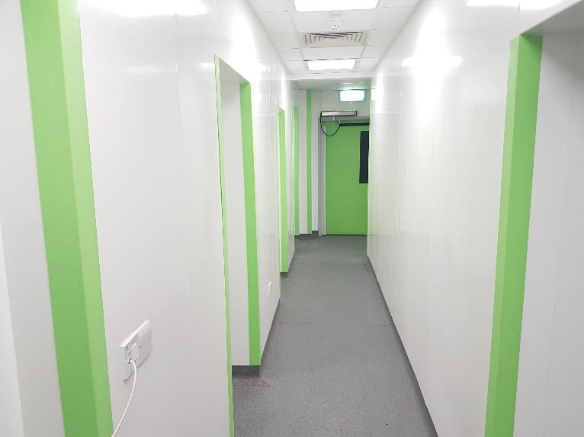
Before Photo, Main Kitchen Washing Up Area

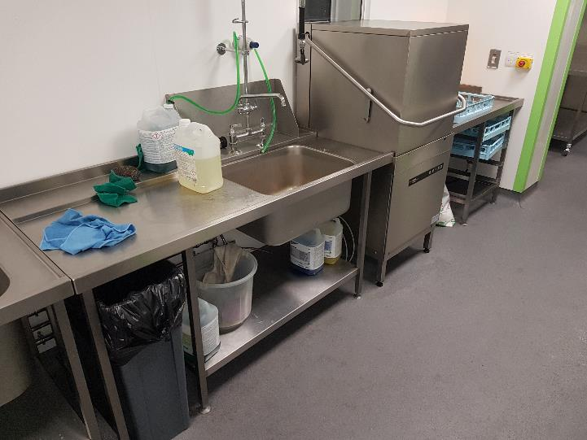

After Photo, Main Kitchen Washing Up Area

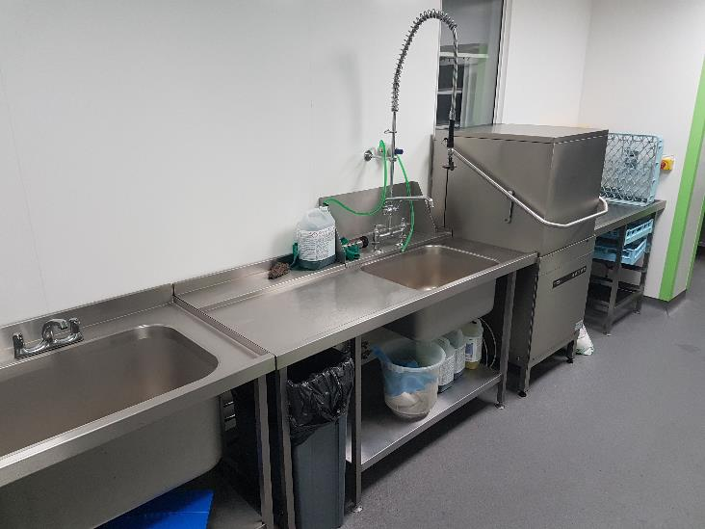

Before Photo, Main Kitchen Prep Area

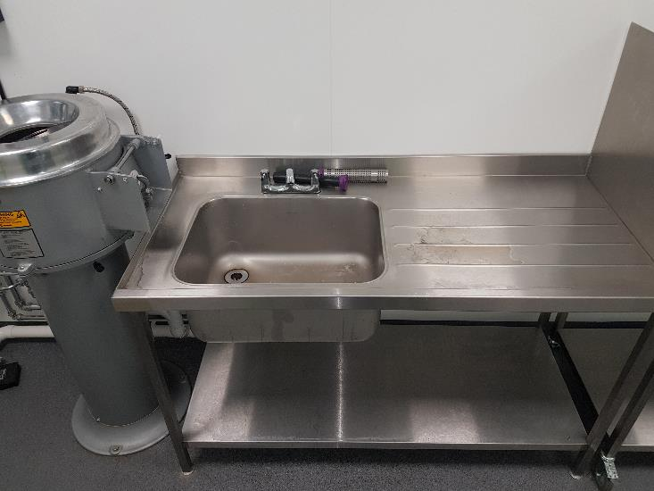

After Photo, Main Kitchen Prep Area

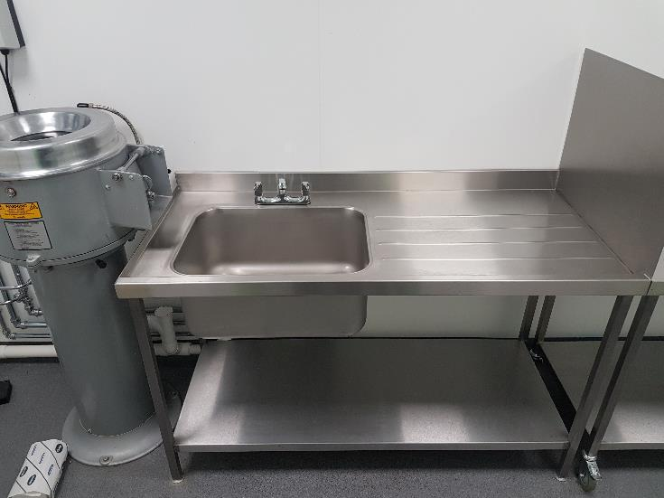

Before Photo, Main Kitchen Cooker

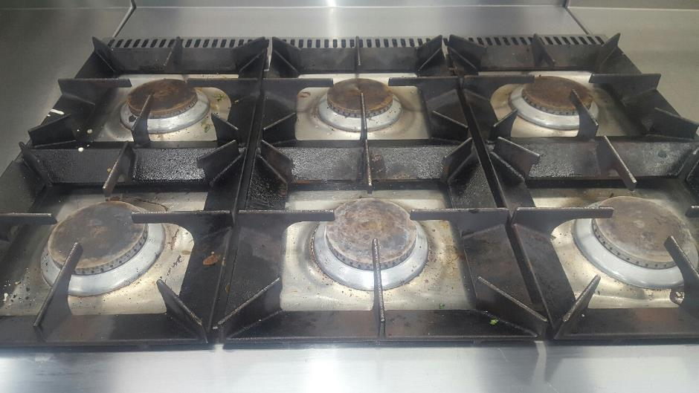

After Photo, Main Kitchen Cooker

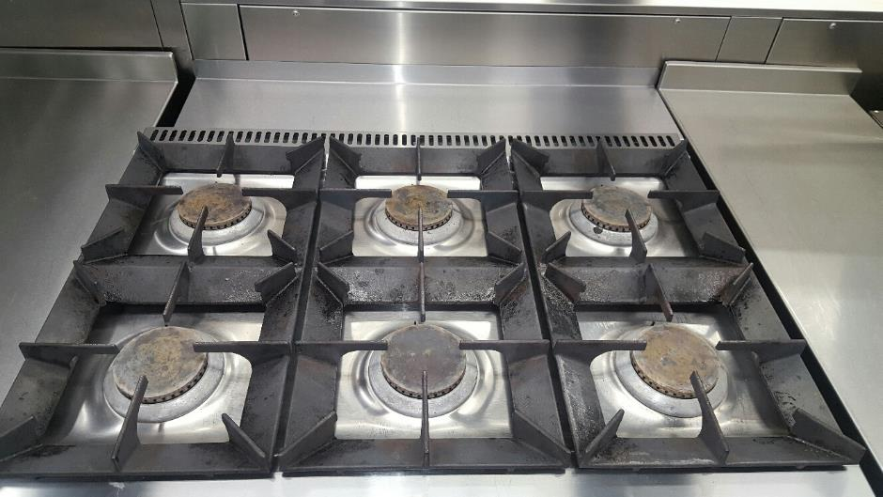

Before Photo, Main Kitchen Oven

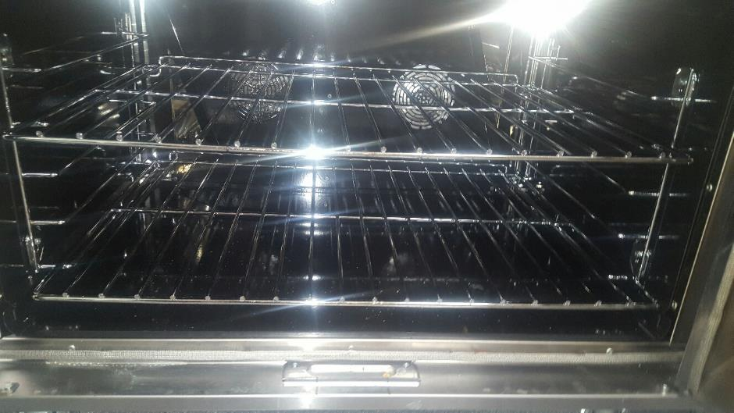

After Photo, Main Kitchen Oven

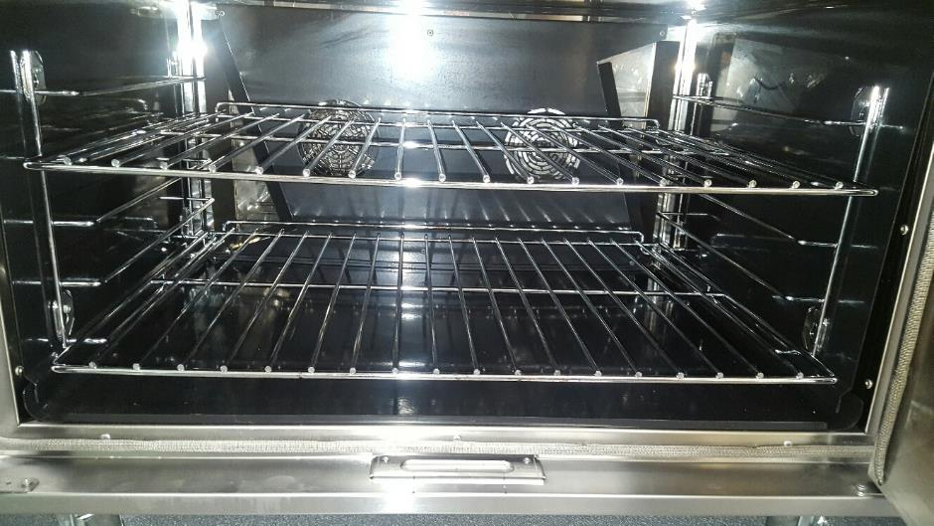

Before Photo, Main Kitchen Fat Fryer

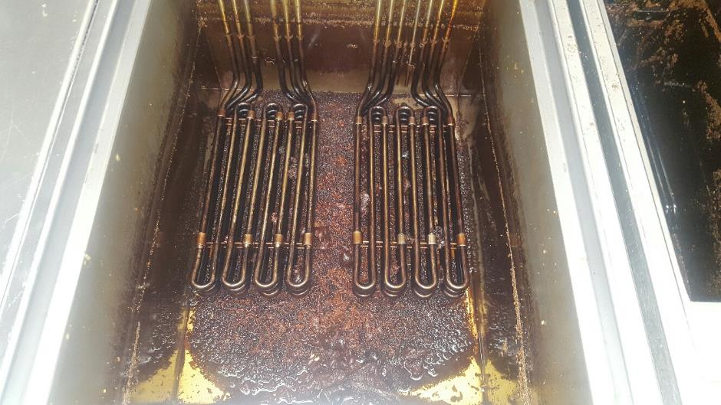

After Photo, Main Kitchen Fat Fryer

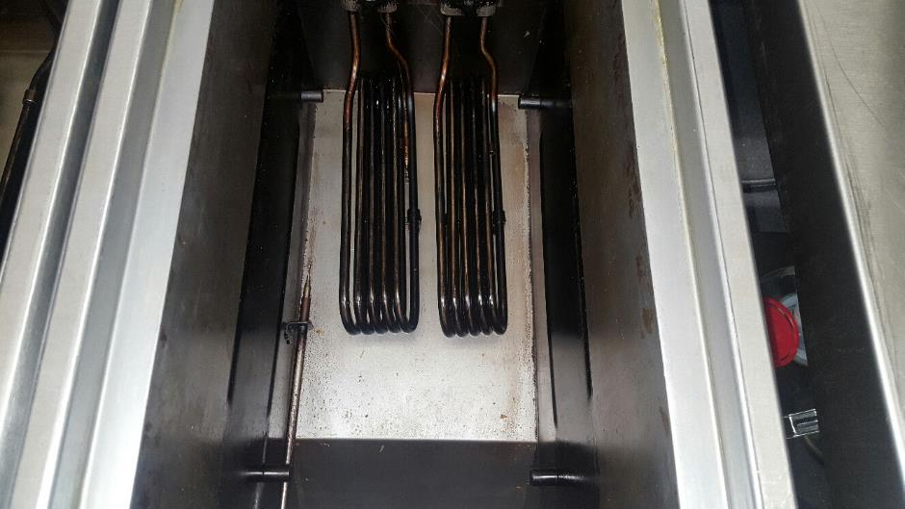

Before Photo, Main Kitchen Steam Oven

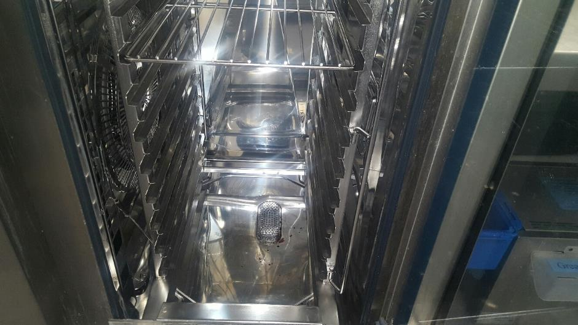

After Photo, Main Kitchen Steam Oven

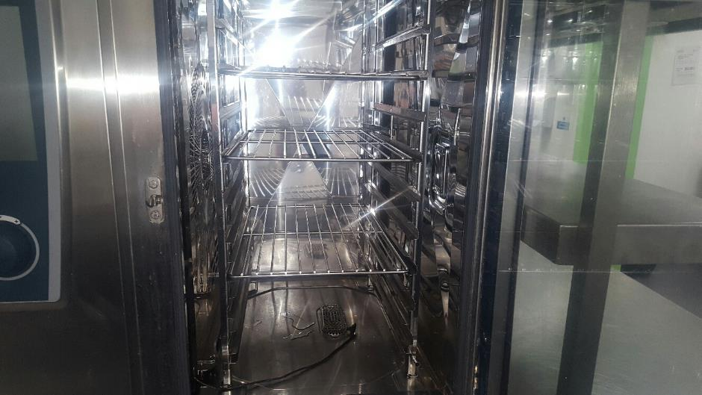

Before Photo, Main Kitchen Steam Oven

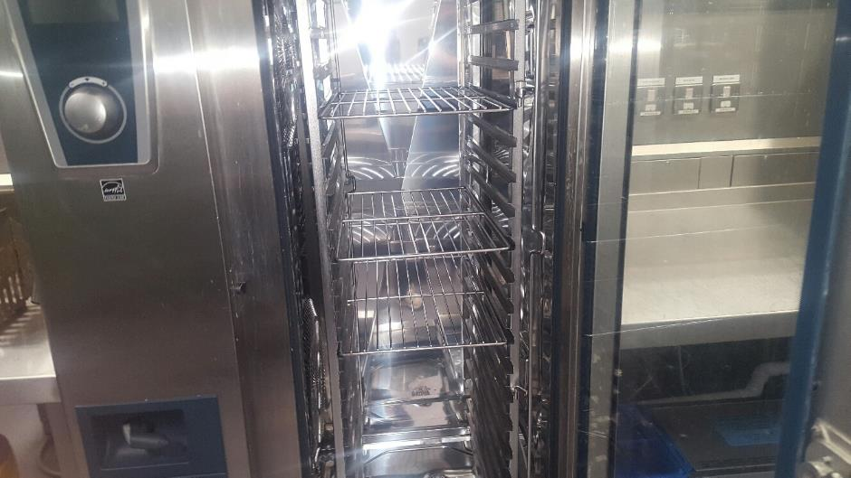

After Photo, Main Kitchen Steam Oven

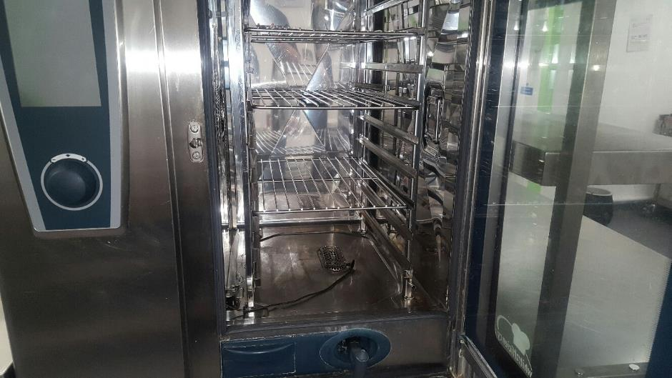

Before Photo, Main Kitchen Floor

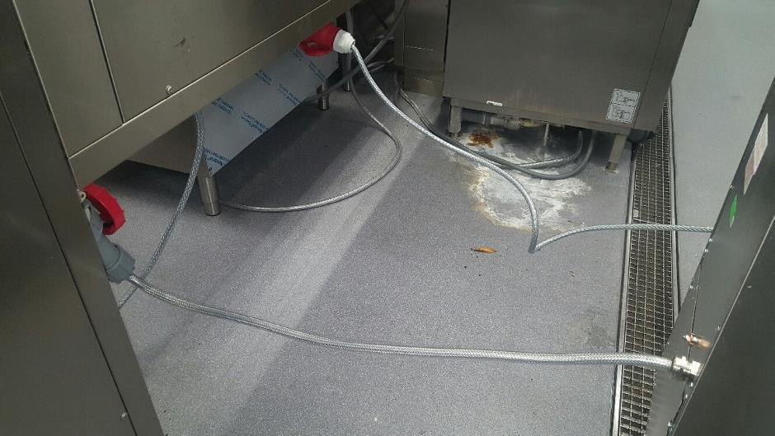

After Photo, Main Kitchen Floor

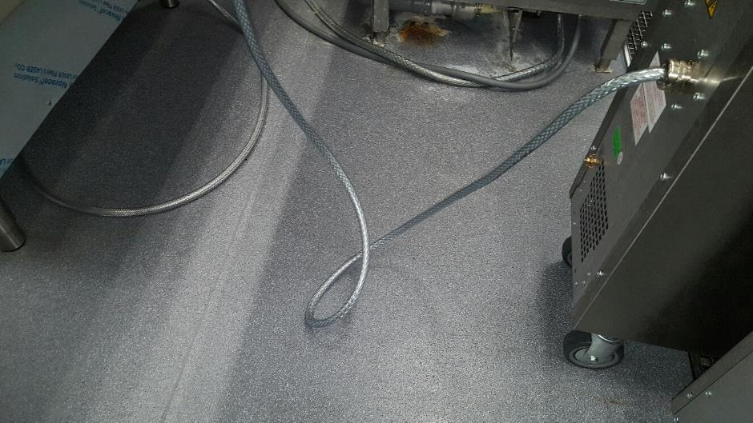

Before Photo, Main Kitchen Floor

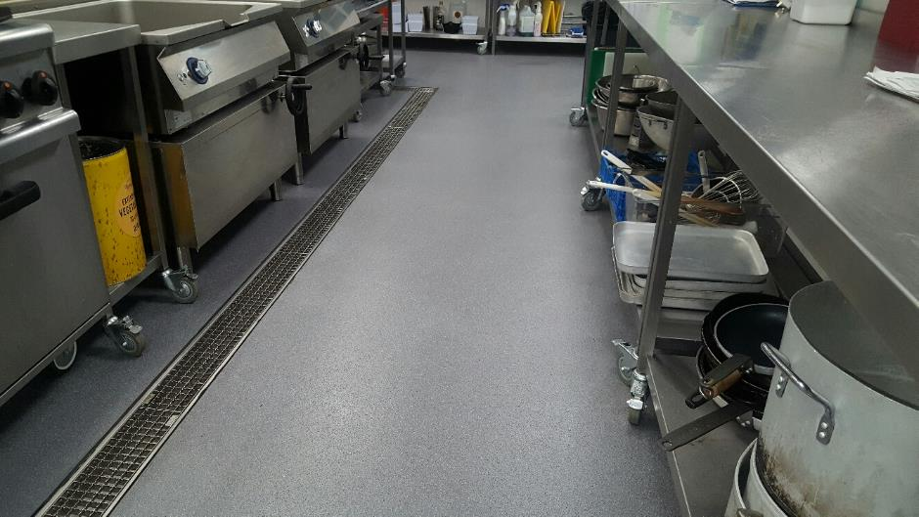

After Photo, Main Kitchen Floor

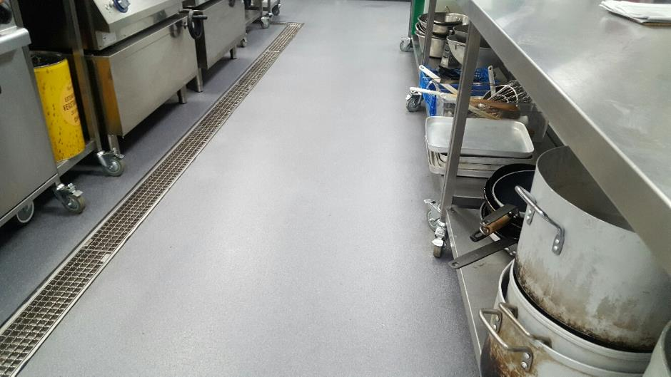

Before Photo, Main Kitchen Canopy

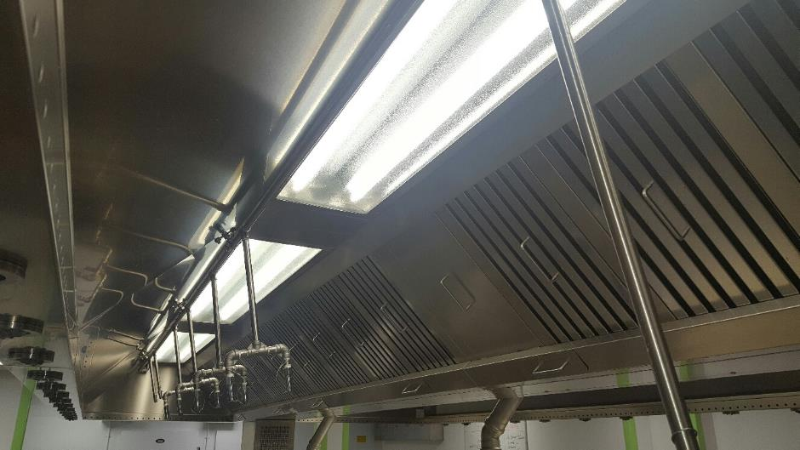

After Photo, Main Kitchen Canopy

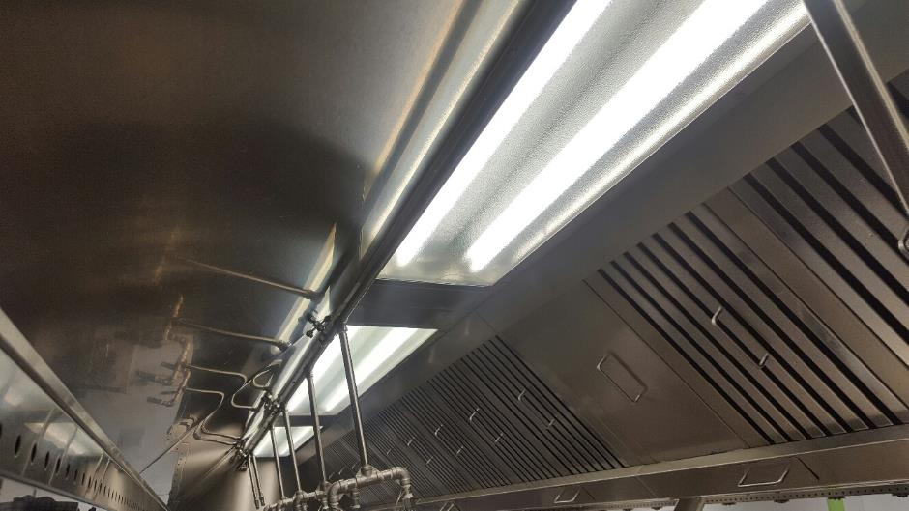

Before Photo, Main Kitchen Canopy

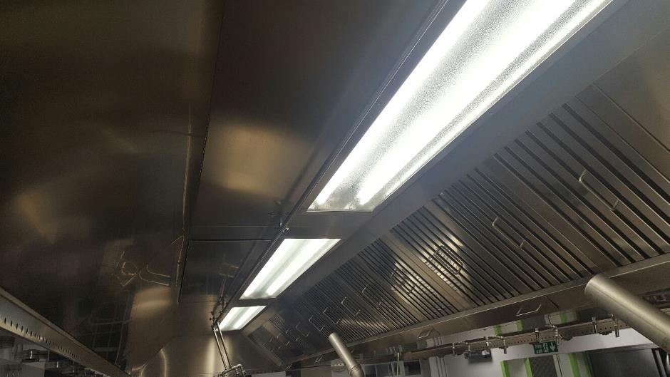

After Photo, Main Kitchen Canopy

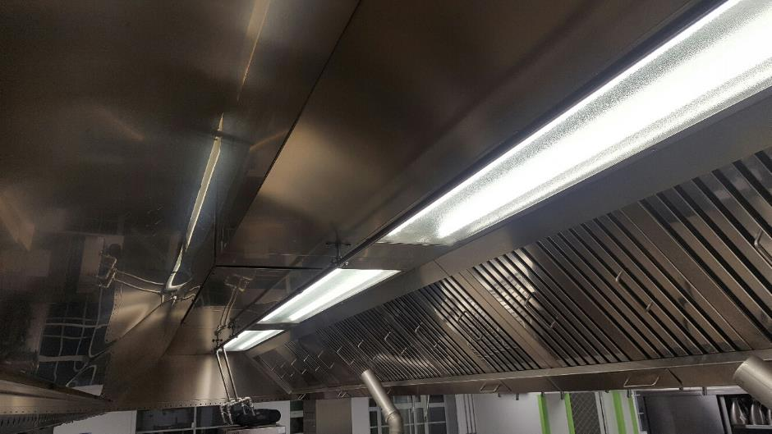

Main servery area

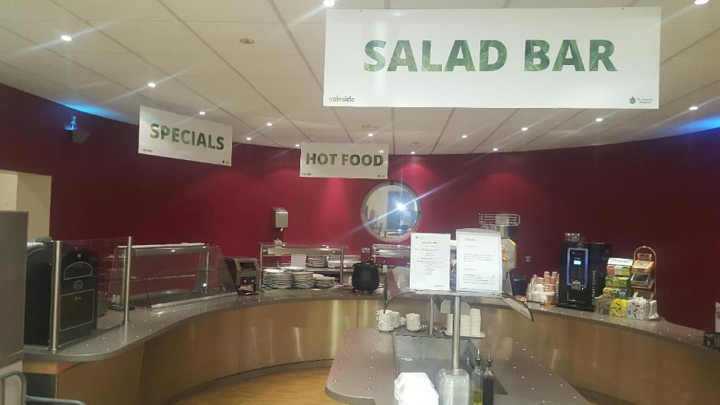

Before Photo, Servery Area Counter

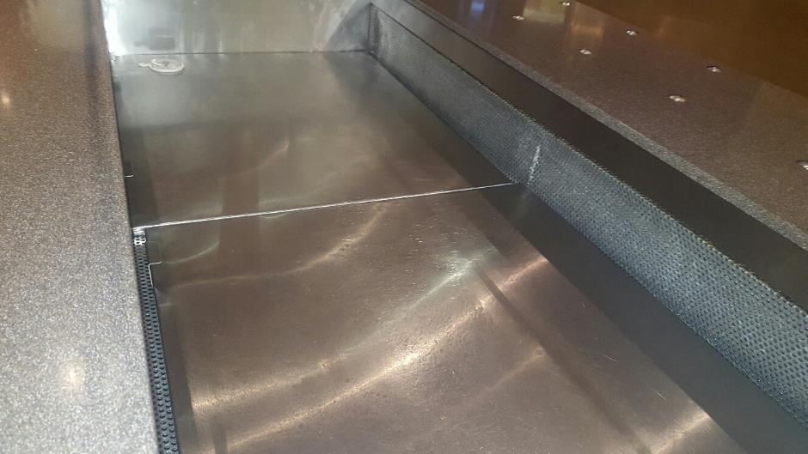

After Photo, Servery Area Counter

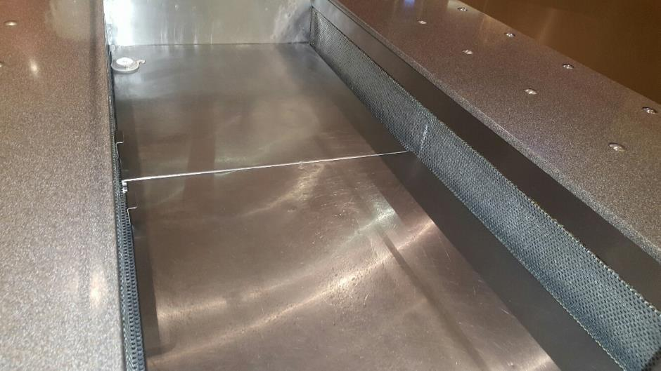

Before Photo, Servery Area Counter

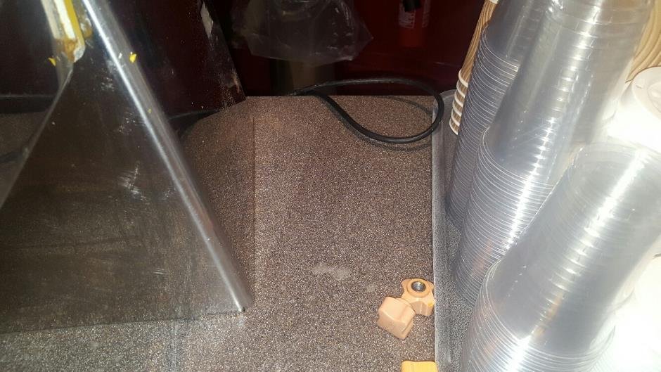

After Photo, Servery Area Counter

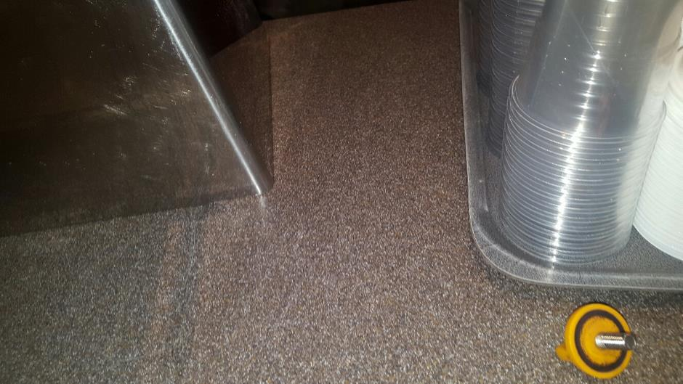

Before Photo, Servery Area Glass Front Counter

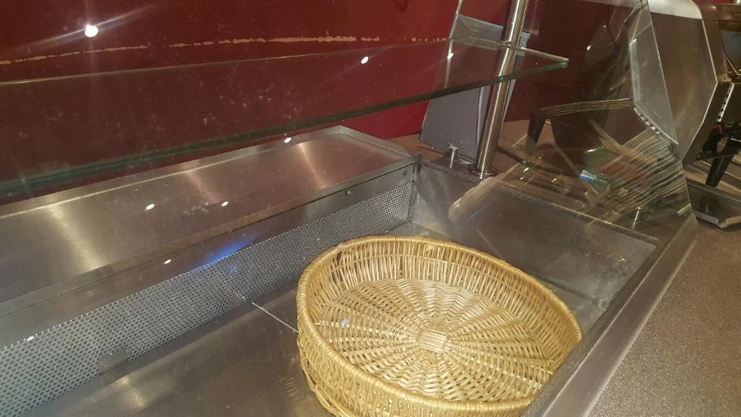

After Photo, Servery Area Glass Front Counter

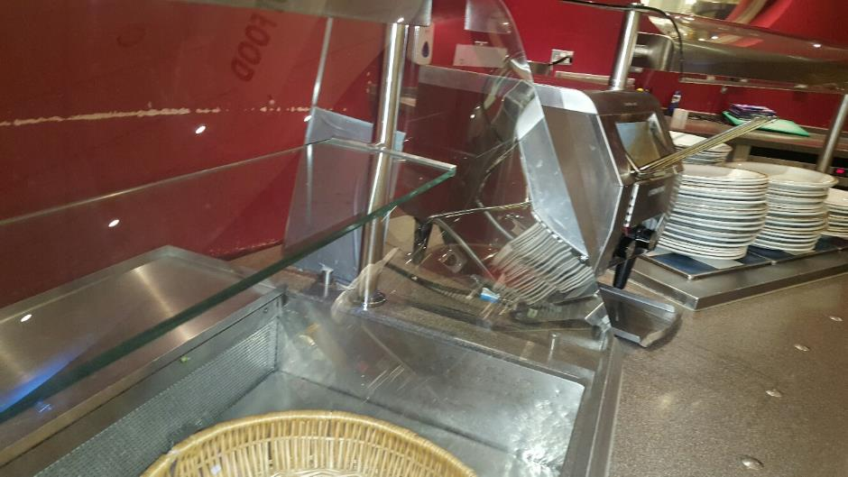

Before Photo, Servery Area Floor

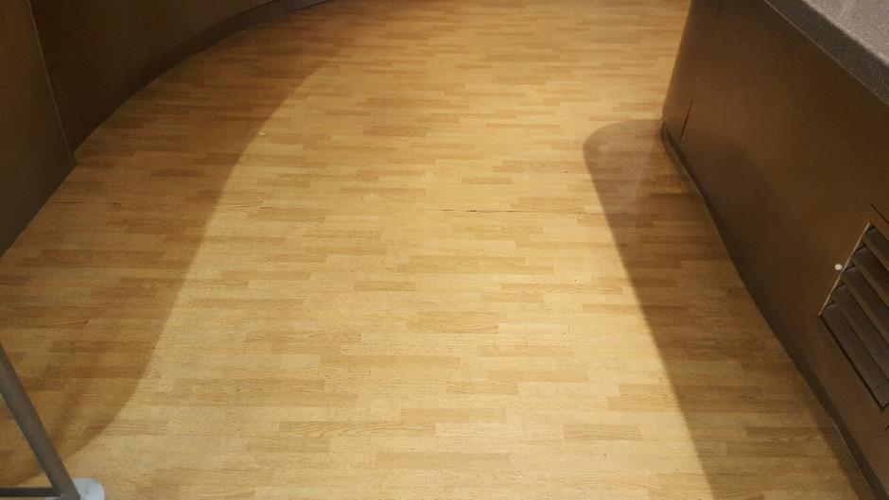

After Photo, Servery Area Floor

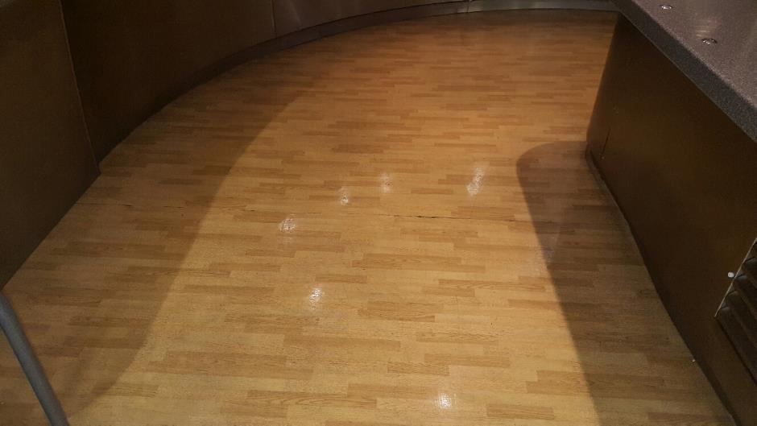

Before Photo, Servery Area Floor

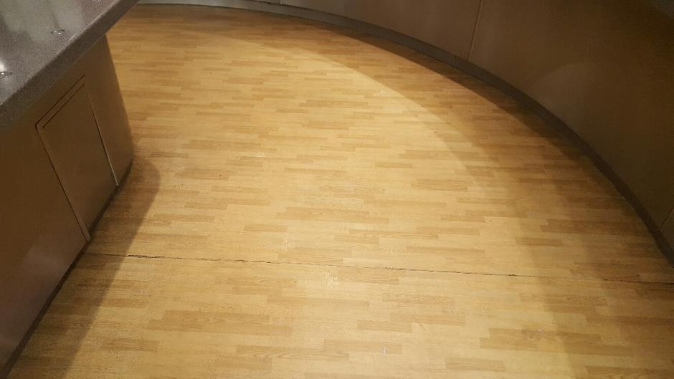

After Photo, Servery Area Floor

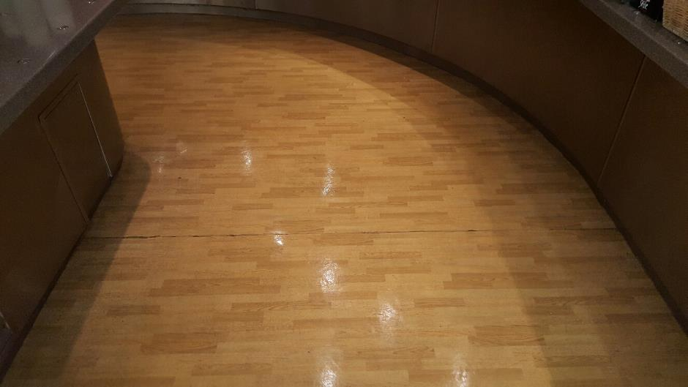

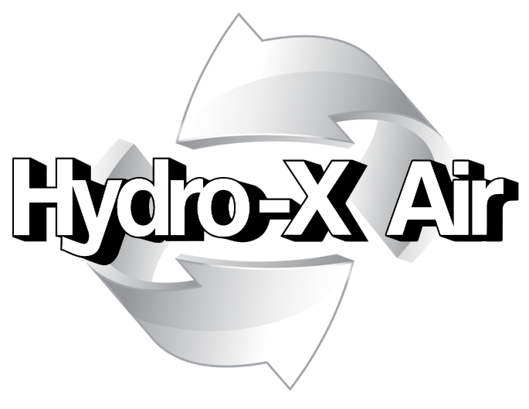

CERTIFICATE OF CLEANING
This is to certify the kitchen at the site named below has been cleaned as set out in the introduction of this report.
.

Customer: | Customer
Site: | Building No1
System Location: | Main kitchen
Date: | 24/04/2020

The kitchen and all catering equipment including walls and floors were hygienically cleaned. On completion of cleaning all surfaces were thoroughly rinsed to remove all chemical residue. Before and after photographs were taken.

Hydro-X Air: | Signature
Print Name: | Site Operative

Compliance House, Unit 11 Abbotts Business Park, Primrose Hill, Kings Langley, Hertfordshire. WD4 8FR
